https://www.jdoodle.com/embed/v0/6d4C
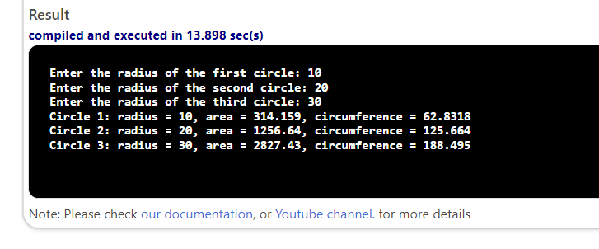

#include <iostream>
using namespace std;

class Circle {
private:
double radius;

public:
Circle(double r) {
radius = r;
}

double findArea() {
return 3.14159 * radius * radius;
}

double findCircumference() {
return 2 * 3.14159 * radius;
}

double getRadius() {
return radius;
}
};

int main() {
double r1, r2, r3;
cout << "Enter the radius of the first circle: ";
cin >> r1;
Circle c1(r1);

cout << "Enter the radius of the second circle: ";
cin >> r2;
Circle c2(r2);

cout << "Enter the radius of the third circle: ";
cin >> r3;
Circle c3(r3);

double area1 = c1.findArea();
double area2 = c2.findArea();
double area3 = c3.findArea();

double circ1 = c1.findCircumference();
double circ2 = c2.findCircumference();
double circ3 = c3.findCircumference();

cout << "Circle 1: radius = " << c1.getRadius() << ", area = " << area1 << ", circumference = " << circ1 << endl;
cout << "Circle 2: radius = " << c2.getRadius() << ", area = " << area2 << ", circumference = " << circ2 << endl;
cout << "Circle 3: radius = " << c3.getRadius() << ", area = " << area3 << ", circumference = " << circ3 << endl;

return 0;
}

